SIMATS ENGINEERING

ITA05 COMPUTER VISION
LAB ACTIVITY :-
1)Perform basic Image Handling and processing operations on the image.
AIM:- Read an image in python and Convert an Image to Grayscale
PROGRAM:-
import cv2
img = cv2.imread ('C:\\Users\\christy\\Desktop\\OpenCV\\image1.jpg')
gray_img = cv2.cvtColor(img, cv2.COLOR_BGR2GRAY)
cv2.imshow('Grayscale', gray_image)
cv2.imwrite('gray_image.jpg', gray_img)
cv2.waitKey(0)
cv2.destroyAllWindows()
INPUT:-
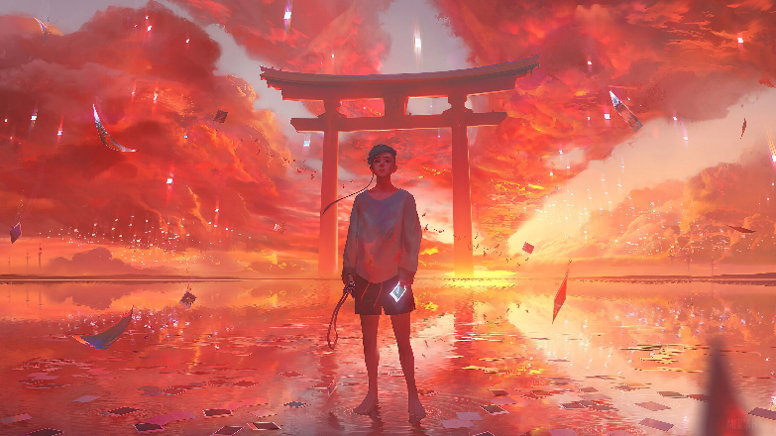

OUTPUT:-
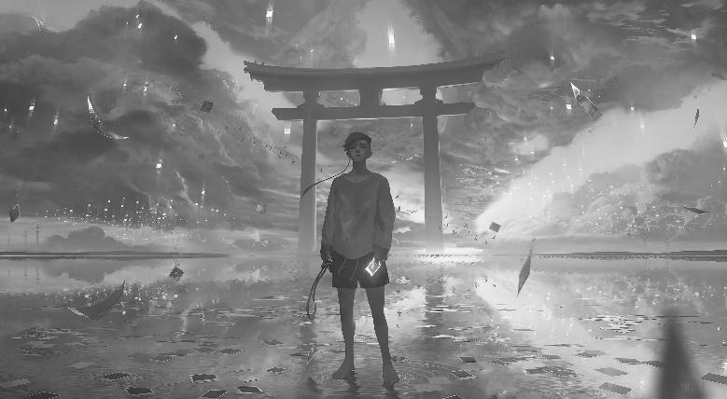
RESULT:-
Thus the program is executed successfully.
2) Perform basic Image Handling and processing operations on the image
AIM:- Read an image in python and Convert an Image to Blur using GaussianBlur.

PROGRAM:-
import cv2
image = cv2.imread('C:\\Users\\girishama\\Desktop\\OpenCV\\image1.jpg')
blur = cv2.GaussianBlur(image, (5, 5), 10)
cv2.imwrite('blurred_image.jpg', blur)
cv2.imshow('Blurred Image', blur)
cv2.waitKey(0)
cv2.destroyAllWindows()
INPUT:-
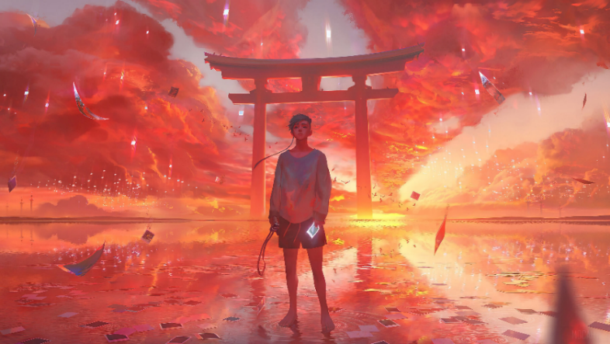

OUTPUT:-
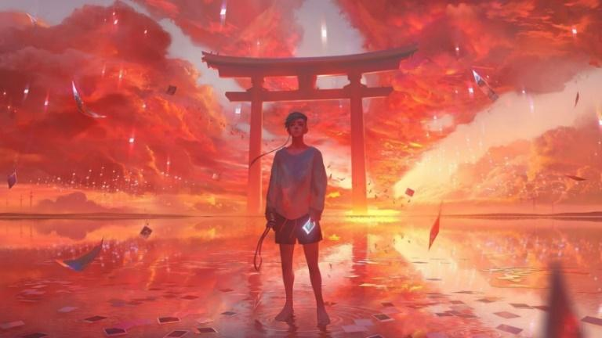
RESULT:-
Thus the program is executed successfully.
3) Perform basic Image Handling and processing operations on the image
AIM:-
Read an image in python and Convert an Image to show outline using Canny function.
PROGRAM:-
import cv2
img = cv2.imread('C:\\Users\\girishama\\Desktop\\OpenCV\\image1.jpg')
gray = cv2.cvtColor(img, cv2.COLOR_BGR2GRAY)
edges = cv2.Canny(gray, 100, 200)
cv2.imwrite('Canny_Edges_3rd.jpg', edges)
cv2.imshow(‘Edges', edges)
cv2.waitKey(0)
cv2.destroyAllWindows()
INPUT:-
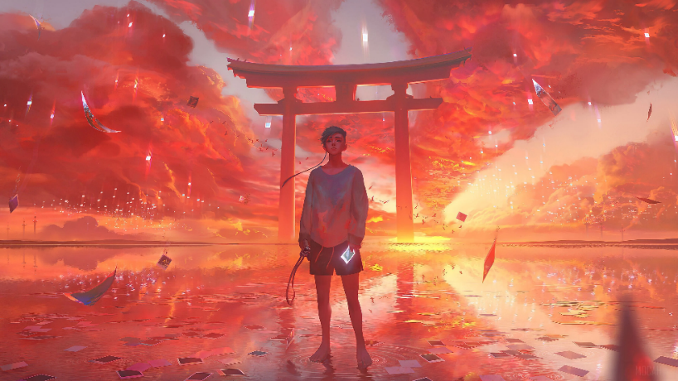
OUTPUT:-
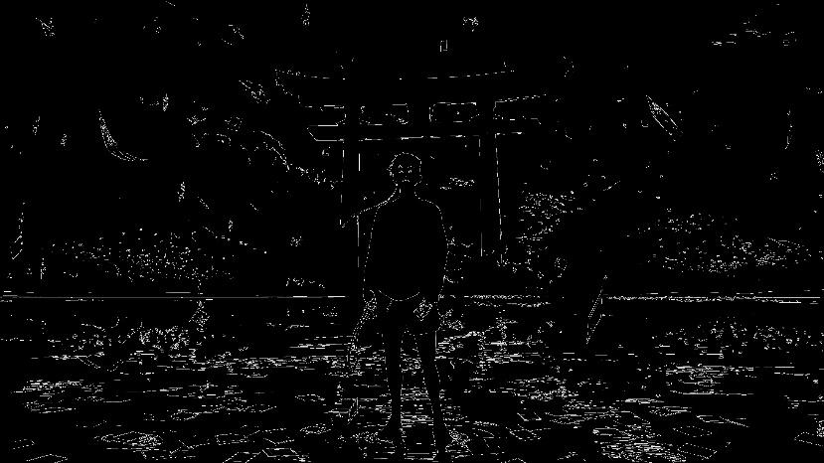
RESULT:-
Thus the program is executed successfully.
4) Perform basic Image Handling and processing operations on the image
AIM:-
Read an image in python and Dilate an Image using Dilate function.
PROGRAM:-
import cv2
import numpy as np
img = cv2.imread(''C:\\Users\\girishma\\Desktop\\OpenCV\\image1.jpg'cv2.IMREAD_GRAYSCALE)
kernel = np.ones((5,5), np.uint8)
dilated_img = cv2.dilate(img, kernel, iterations=1)
cv2.imwrite('Dilated_Image.jpg', dilated_img)
INPUT:-
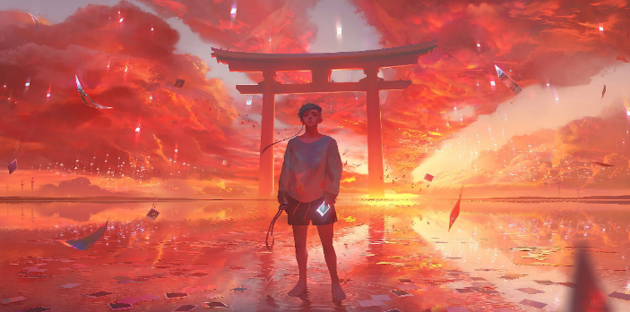
OUTPUT:-
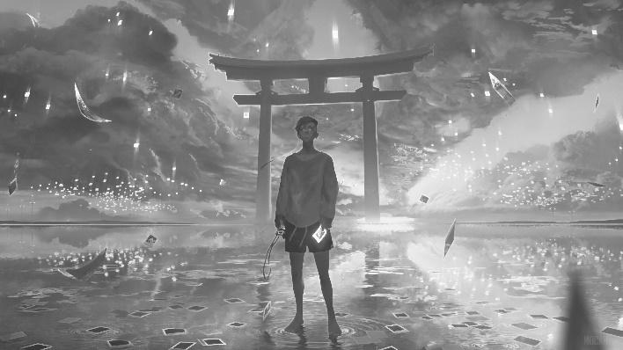
RESULT:-
Thus the program is executed successfully.
5. Perform basic Image Handling and processing operations on the image
AIM:-
Read an image in python and Erode an Image using erode function
PROGRAM:-
import cv2
import numpy as np
img = cv2.imread("C:\\Users\\girishma\\Desktop\\OpenCV\\image1.jpg")
gray_image = cv2.cvtColor(img, cv2.COLOR_BGR2GRAY)
kernel = cv2.getStructuringElement(cv2.MORPH_RECT, (5, 5))
eroded_image = cv2.erode(gray_image, kernel, iterations=1)
cv2.imwrite("eroded_image.jpg",eroded_image)
INPUT:-
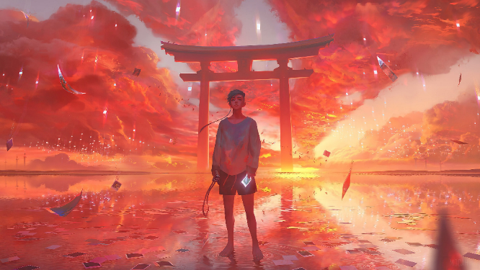
OUTPUT:-
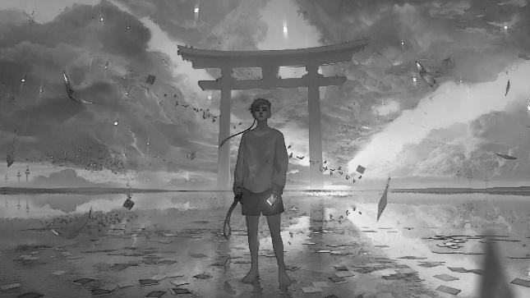
RESULT:-
Thus the program is executed successfully.
6. Perform basic video processing operations on the captured video
AIM:- Read captured video in python and display the video, in slow motion and in fast motion.
PROGRAM:-
import cv2
cap = cv2.VideoCapture("C:\\Users\\girishma\\Desktop\\OpenCV\\image1.jpg"))
slow_factor = 0.5
fast_factor = 2.0
ret, frame = cap.read()
while ret:
cv2.imshow('Slow Motion', cv2.resize(frame, None, fx=slow_factor, fy=slow_factor))
cv2.imshow('Fast Motion', cv2.resize(frame, None, fx=fast_factor, fy=fast_factor))
if cv2.waitKey(1) & 0xFF == ord('q'):
break
ret, frame = cap.read()
cap.release()
cv2.destroyAllWindows()
#TO RUN THIS CODE” video/demonslayer.mp4 at main · Muttamatam-Sreeharsha-0471/video (github.com)”DOWNLOAD VIDEO VIA THIS LINK
RESULT:-
Thus the program is executed successfully.
7)
AIM:-Capture video from web Camera and Display the video, in slow motion and in fast motion. operations on the captured video
PROGRAM:-
import cv2
cap = cv2.VideoCapture("C:\\Users\\girishma\\Desktop\\OpenCV\\image1.jpg"))
slow_factor = 0.5
fast_factor = 2.0
ret, frame = cap.read()
while ret:
cv2.imshow('Slow Motion', cv2.resize(frame, None, fx=slow_factor, fy=slow_factor))
cv2.imshow('Fast Motion', cv2.resize(frame, None, fx=fast_factor, fy=fast_factor))
if cv2.waitKey(1) & 0xFF == ord('q'):
break
ret, frame = cap.read()
cap.release()
cv2.destroyAllWindows()
RESULT:-
Thus the program is executed successfully.

8. Scaling an image to its Bigger and Smaller sizes.
AIM:-Converting an image to image to its Bigger and Smaller sizes.
PROGRAM:-
import cv2
image = cv2.imread("C:\\Users\\girishma\\Desktop\\OpenCV\\image1.jpg"))
height, width = image.shape[:2]

scale_factor = 3.0
bigger_image = cv2.resize(image,(int(width*scale_factor),
int(height*scale_factor)))

scale_factor = 0.5
smaller_image = cv2.resize(image,(int(width*scale_factor),
int(height*scale_factor)))

cv2.imshow('original image',image)
cv2.imshow('Bigger image',bigger_image)
cv2.imshow('smaller image',smaller_image)

cv2.imwrite("Bigger_image.jpg",bigger_image)
cv2.imwrite("smaller_image.jpg",smaller_image)
INPUT:-

OUTPUT:-
Bigger image:-
Smaller image:-
RESULT:-
Thus the program is executed successfully.
9. Perform Rotation of an image to clockwise and counter clockwise direction.
AIM:-
Rotation of an image to clockwise and counter clockwise direction.
PROGRAM:-
import cv2
img = cv2.imread("C:\\Users\\girishma\\Desktop\\OpenCV\\image1.jpg"))
# Rotate clockwise
rotated_img = cv2.rotate(img, cv2.ROTATE_90_CLOCKWISE)
# Rotate counterclockwise
rotated_img = cv2.rotate(img, cv2.ROTATE_90_COUNTERCLOCKWISE)
cv2.imwrite("rotated_image.jpg",rotated_img)

INPUT:-
OUTPUT:-
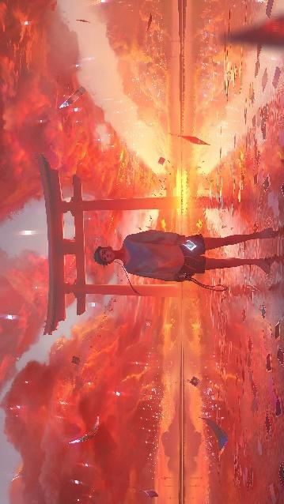
RESULT:-
Thus the program is executed successfully.
10. Perform moving of an image from one place to another.
AIM:- Moving of an image from one place to another.
PROGRAM:-
import cv2
image = cv2.imread("C:\\Users\\sree\\Desktop\\OpenCV\\image1.jpg")
width = image.shape[1]
height = image.shape[0]
new_image = cv2.imread("C:\\Users\\girishma\\Desktop\\OpenCV\\image1.jpg"))
current_position = cv2.getWindowProperty("Original Image", cv2.WND_PROP_POSITION)
cv2.moveWindow("Original Image", current_position[0] + 100, current_position[1] + 100)
cv2.imshow("Original Image", image)
cv2.waitKey(0)
cv2.destroyAllWindows()
OUTPUT:-
The image will move from one position to another.
RESULT:-
Thus the program is executed successfully.
11. Perform Affine Transformation on the image.
AIM:- Affine Transformation on the image
PROGRAM:-
import cv2
import numpy as np
img = cv2.imread("C:\\Users\\girishma\\Desktop\\OpenCV\\image1.jpg")
rows, cols = img.shape[:2]
M = np.float32([[1, 0, 1000], [0, 1, 500]])
affine_img = cv2.warpAffine(img, M, (cols, rows))
cv2.imwrite('Affine_Transformed.jpg', affine_img)
INPUT:-
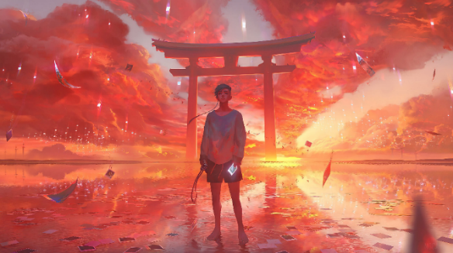
OUTPUT:-
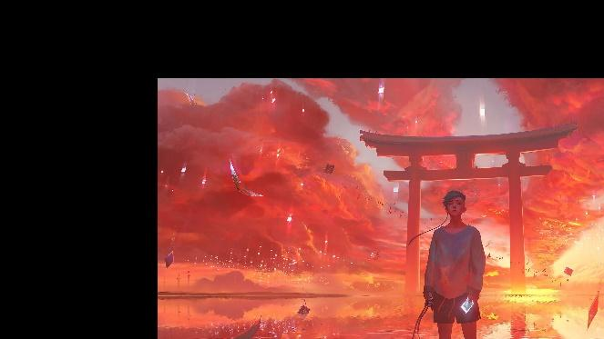
RESULT:-
Thus the program is executed successfully.
12. Perform Perspective Transformation on the image.
AIM:- Perspective Transformation on the image.
PROGRAM:-
import cv2
import numpy as np
img = cv2.imread("C:\\Users\\girishma\\Desktop\\OpenCV\\image1.jpg"))
rows, cols = img.shape[:2]
src_points = np.float32([[0, 0], [cols - 1, 0], [0, rows - 1], [cols - 1, rows - 1]])
dst_points = np.float32([[0, 0], [cols - 1, 0], [int(0.33*cols), rows - 1], [int(0.66*cols), rows - 1]])
M = cv2.getPerspectiveTransform(src_points, dst_points)
perspective_img = cv2.warpPerspective(img, M, (cols, rows))
cv2.imwrite('Perspective_Transformed_Image.jpg', perspective_img)
INPUT:-
OUTPUT:-
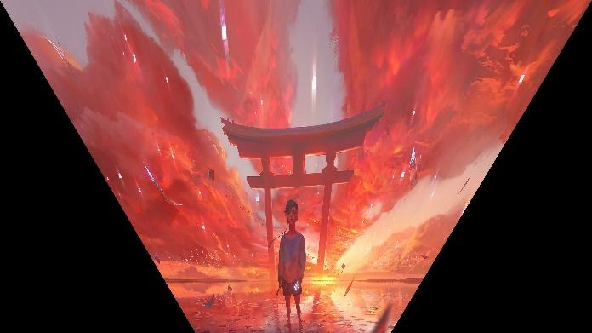
RESULT:-
Thus the program is executed successfully.
13. Perform Perspective Transformation on the Video.
AIM:- Perspective Transformation on the Video
PROGRAM:-
import cv2
import numpy as np
roi_points = np.array([(150, 200), (450, 200), (550, 500), (50, 500)])
target_points = np.array([(0, 0), (400, 0), (400, 600), (0, 600)])
M = cv2.getPerspectiveTransform(roi_points.astype(np.float32), target_points.astype(np.float32))
cap = cv2.VideoCapture(0)
while True:
ret, frame = cap.read()
if not ret:
break
dst = cv2.warpPerspective(frame, M, (400, 600))
cv2.imshow("Original Frame", frame)
cv2.imshow("Transformed Frame", dst)
if cv2.waitKey(1) & 0xFF == ord('q'):
break
cap.release()
cv2.destroyAllWindows()
RESULT:-
It will access the cam and transform your own live video
14. Perform transformation using Homography matrix.
AIM:- transformation using Homography matrix
PROGRAM:-
import cv2
import numpy as np
img = cv2.imread("C:\\Users\\girishma\\Desktop\\OpenCV\\image1.jpg")
rows, cols = img.shape[:2]
src_points = np.float32([[0, 0], [cols - 1, 0], [0, rows - 1], [cols - 1, rows - 1]])
dst_points = np.float32([[0, 0], [cols - 1, 0], [0, int(0.7*rows)], [cols - 1, int(0.7*rows)]])
M, _ = cv2.findHomography(src_points, dst_points)
homography_img = cv2.warpPerspective(img, M, (cols, rows))
cv2.imwrite('transformation_using_Homography_Image.jpg', homography_img)
INPUT:-

OUTPUT:-
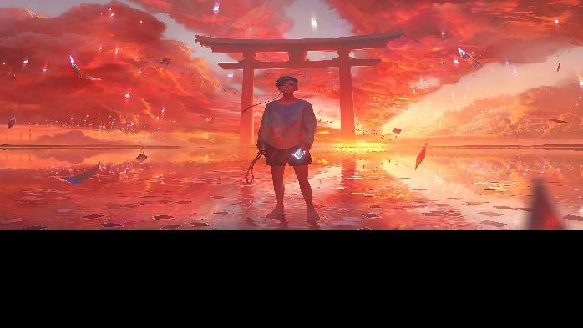
RESULT:-
Thus the program is executed successfully.
15. Perform transformation using Direct Linear Transformation.
AIM:- Transformation using Direct Linear Transformation.
PROGRAM:-
INPUT:-
OUTPUT:-
16. Perform Edge detection using canny method
AIM:- Edge detection using canny method
PROGRAM:-
import cv2
import numpy as np
img = cv2.imread("C:\\Users\\girishma\\Desktop\\OpenCV\\image1.jpg",0)
edges = cv2.Canny(img,100,200)
cv2.imwrite('Edges.jpg',edges)
INPUT:-
OUTPUT:-
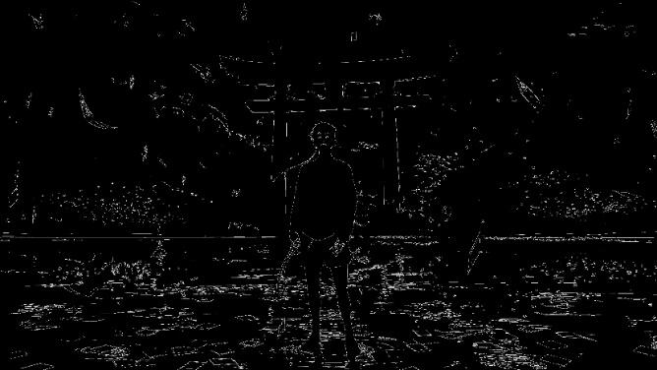
RESULT:-
Thus the program is executed successfully.
17. Perform Edge detection using Sobel Matrix along X axis
AIM:- Edge detection using Sobel Matrix along X axis
PROGRAM:-
import cv2
import numpy as np
img = cv2.imread("C:\\Users\\girishma\\Desktop\\OpenCV\\image1.jpg",0)
sobel_x = cv2.Sobel(img,cv2.CV_8U,1,0,ksize=5)
cv2.imwrite('sobel_x.jpg',sobel_x)
INPUT:-
OUTPUT:-
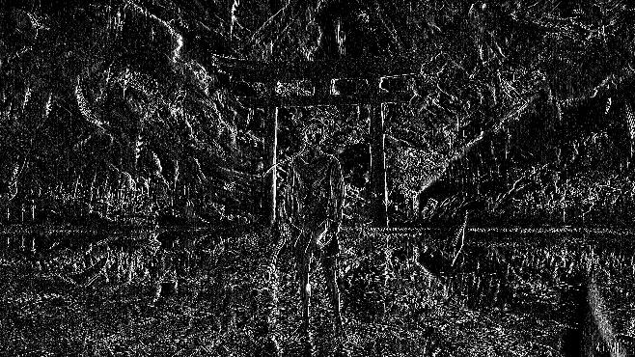
RESULT:-
Thus the program is executed successfully.
18. Perform Edge detection using Sobel Matrix along Y axis
AIM:- Edge detection using Sobel Matrix along Y axis
PROGRAM:-
import cv2
import numpy as np
img = cv2.imread('C:\\Users\\girishma\\Desktop\\OpenCV\\image1.jpg',0)
sobel_y = cv2.Sobel(img,cv2.CV_8U,0,1,ksize=5)
cv2.imwrite('sobel_y.jpg',sobel_y)
INPUT:-
OUTPUT:-
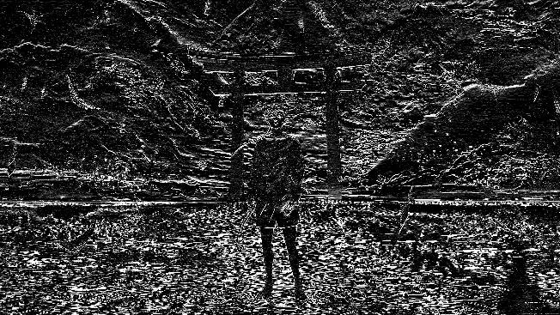
RESULT:-
Thus the program is executed successfully.
19. Perform Edge detection using Sobel Matrix along XY axis
AIM:- Edge detection using Sobel Matrix along XY axis
PROGRAM:-
import cv2
import numpy as np
img = cv2.imread("C:\\Users\\girishma\\Desktop\\OpenCV\\image1.jpg", 0)
sobelx = cv2.Sobel(img, cv2.CV_64F, 1, 0, ksize=3)
sobely = cv2.Sobel(img, cv2.CV_64F, 0, 1, ksize=3)
edges = cv2.addWeighted(sobelx, 0.5, sobely, 0.5, 0)
cv2.imwrite('Edge_detection.jpg', edges)
INPUT:-
OUTPUT:-
RESULT:-
Thus the program is executed successfully.
20. Perform Sharpening of Image using Laplacian mask with negative center coefficient.
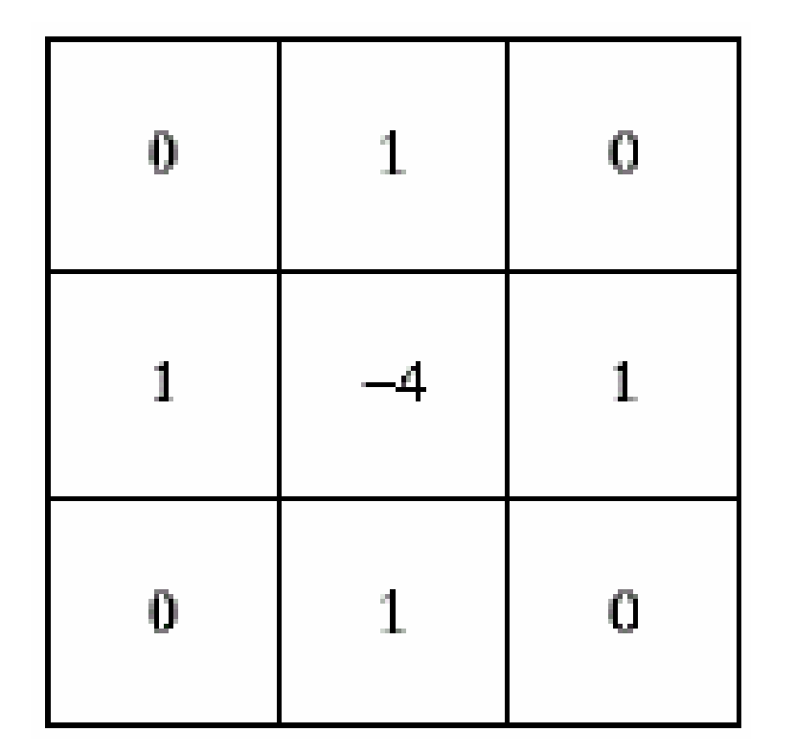
AIM:- Sharpening of Image using Laplacian mask with negative center coefficient.
PROGRAM:-
import cv2
import numpy as np
img = cv2.imread("C:\\Users\\girishma\\Desktop\\OpenCV\\image1.jpg")
kernel = np.array([[0,1,0], [1,-4,1], [0,1,0]])
sharpened = cv2.filter2D(img, -1, kernel)
cv2.imwrite('Sharpened_Image.jpg', sharpened)
INPUT:-
OUTPUT:-
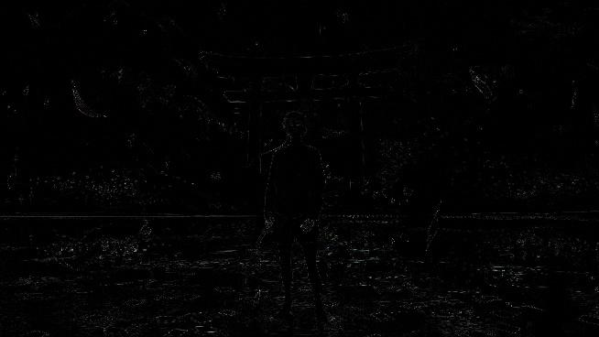
RESULT:-
Thus the program is executed successfully.
21. Perform Sharpening of Image using Laplacian mask implemented with an extension of diagonal neighbors.
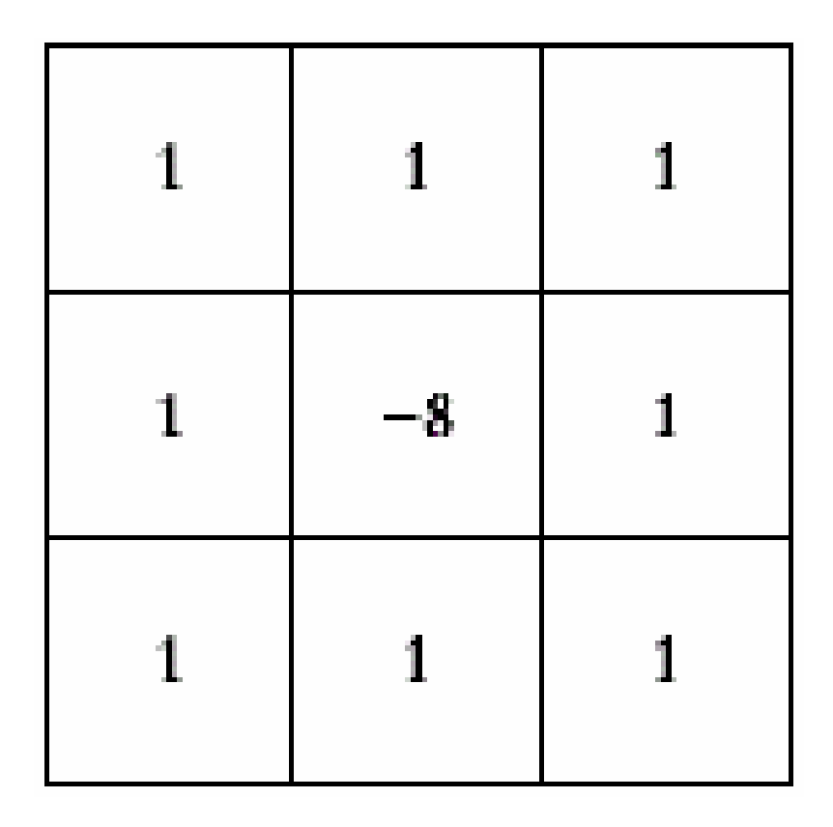
AIM:- Perform Sharpening of Image using Laplacian mask implemented with an extension of diagonal neighbors.
PROGRAM:-
import cv2
import numpy as np
img = cv2.imread("C:\\Users\\girishma\\Desktop\\OpenCV\\image1.jpg")
kernel = np.array([[1,1,1], [1,-8,1], [1,1,1]])
sharpened = cv2.filter2D(img, -1, kernel)
cv2.imwrite('Sharpened_Image.jpg', sharpened)
INPUT:-
OUTPUT:-
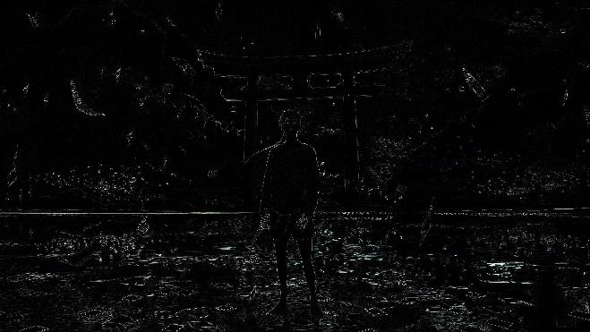
RESULT:-
Thus the program is executed successfully.
22. Perform Sharpening of Image using Laplacian mask with positive center coefficient.
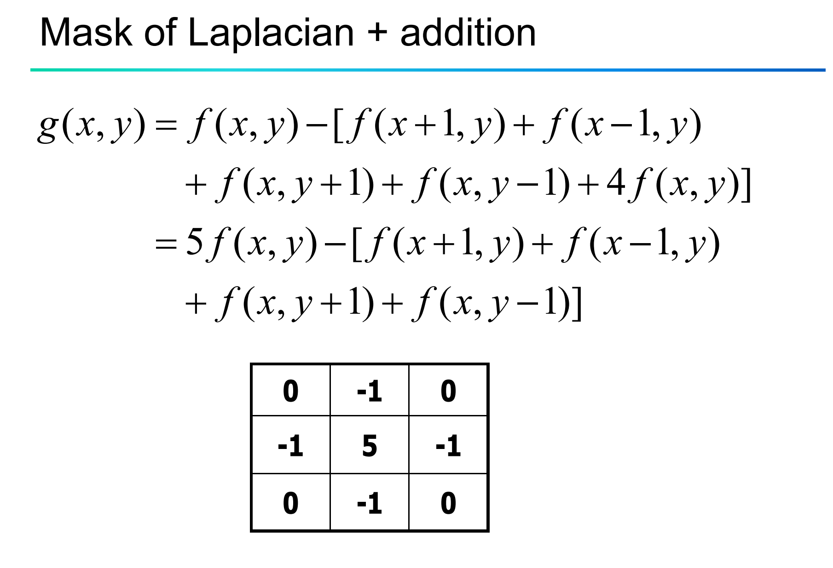
AIM:- Sharpening of Image using Laplacian mask with positive center coefficient.
PROGRAM:-
import cv2
import numpy as np
image = cv2.imread("C:\\Users\\girishma\\Desktop\\OpenCV\\image1.jpg")
kernel = np.array([[0, 1, 0],
[1, -8, 1],
[0, 1, 0]])
sharpened = cv2.filter2D(image, -1, kernel)
cv2.imshow('Original', image)
cv2.imshow('Sharpened.jpg', sharpened)

INPUT:-
OUTPUT:-
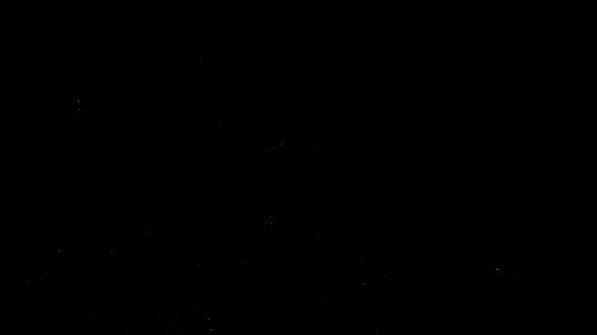
RESULT:-Thus the program is executed successfully.
23. Perform Sharpening of Image using unsharp masking.
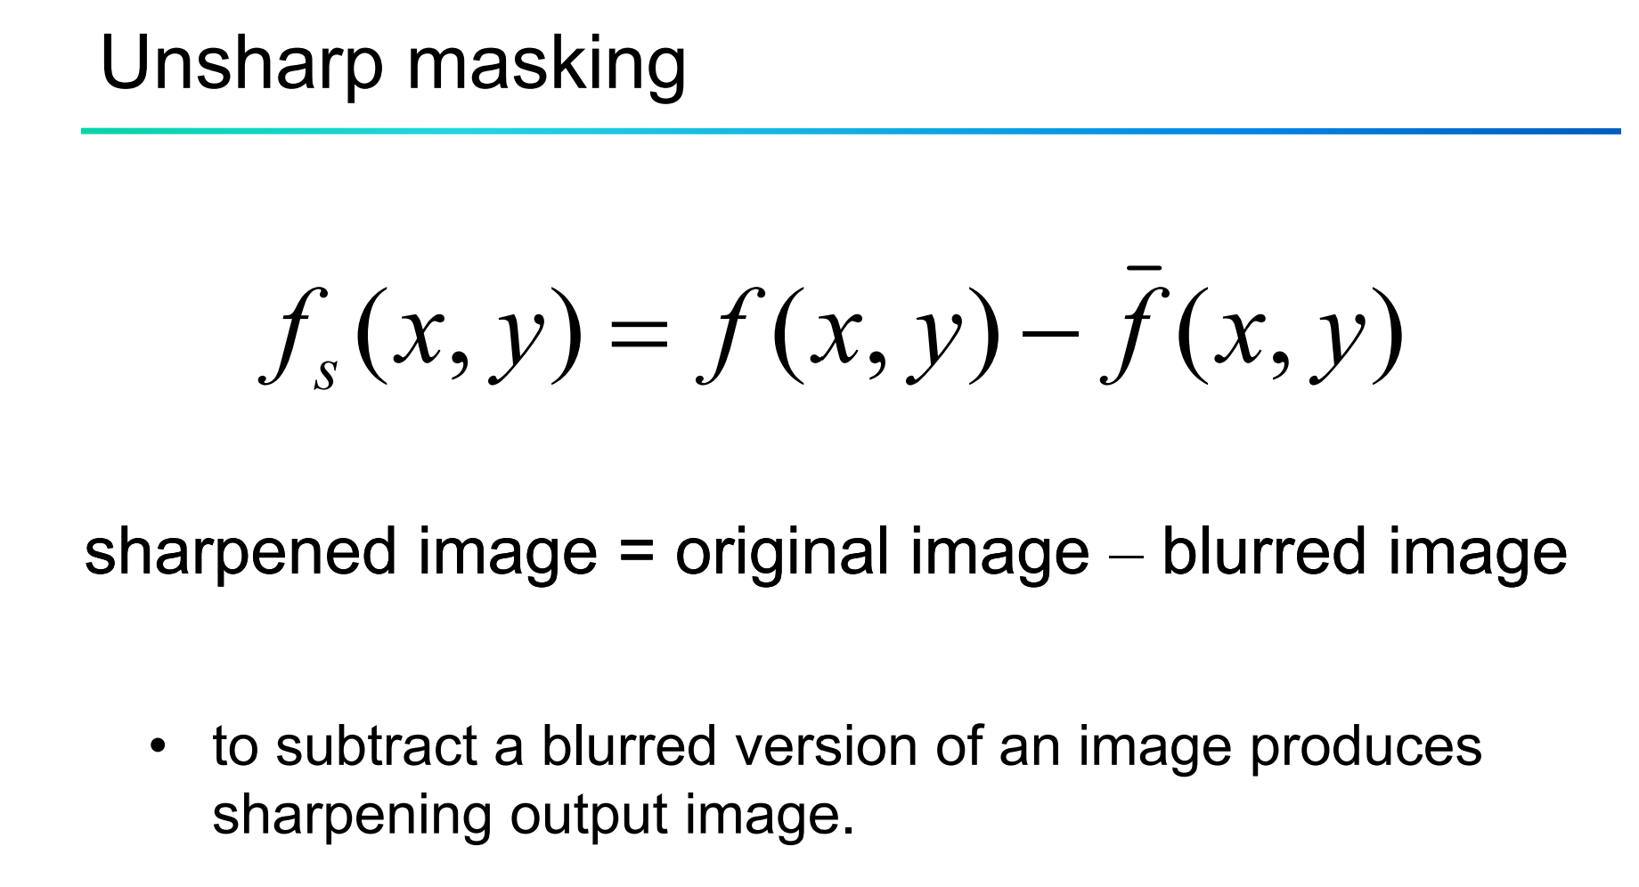
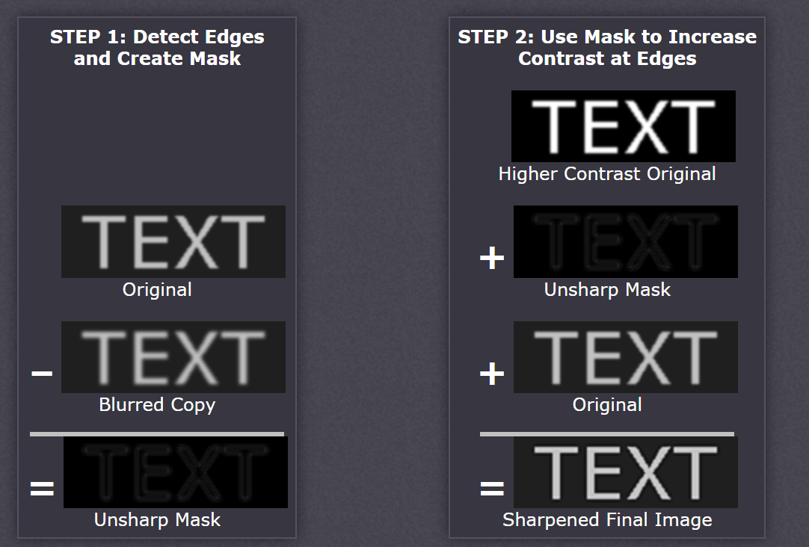
AIM:- Sharpening of Image using unsharp masking.
PROGRAM:-
from PIL import Image, ImageFilter
image_path = "C:\\Users\\girishma\\Desktop\\OpenCV\\image1.jpg"
im1 = Image.open(image_path)
im2 = im1.filter(ImageFilter.UnsharpMask(radius=3, percent=200, threshold=5))
im2.show()
INPUT:-
OUTPUT:-
RESULT:-
Thus the program is executed successfully.

24. Perform Sharpening of Image using High-Boost Masks.
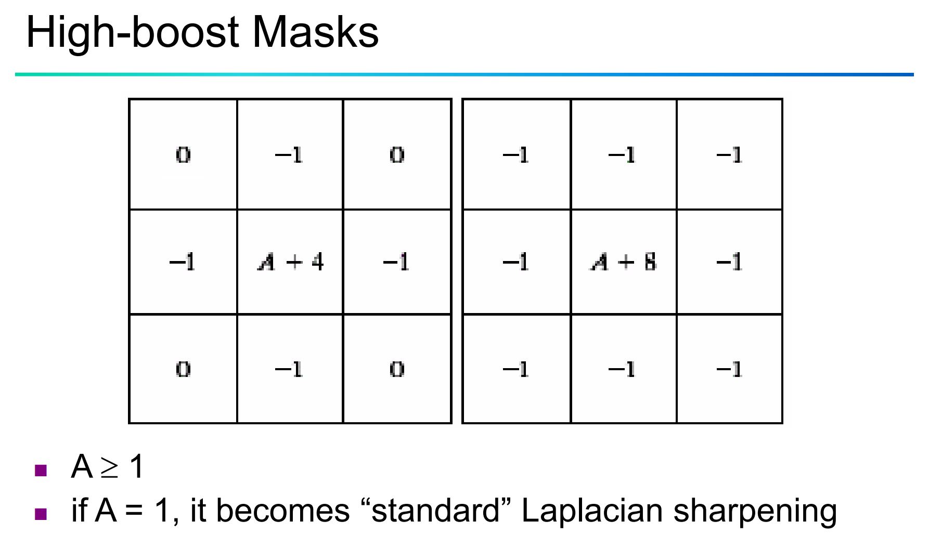
AIM:- Sharpening of Image using High-Boost Masks.
PROGRAM:-
import cv2
import numpy as np
def high_boost_filter(image, boost_factor):
kernel_size = 3
blur_factor = (kernel_size - 1) / 2
kernel = np.ones((kernel_size, kernel_size), dtype=np.float32) / (kernel_size ** 2)
blur_image = cv2.filter2D(image, -1, kernel)
mask = image + (image - blur_image) * boost_factor
return mask
image_path = "C:\\Users\\girishma\\Desktop\\OpenCV\\image1.jpg"
image = cv2.imread(image_path)
sharpened_image = high_boost_filter(image, 1.5)
cv2.imwrite('sharpened_image.jpg', sharpened_image)
INPUT:-
OUTPUT:-
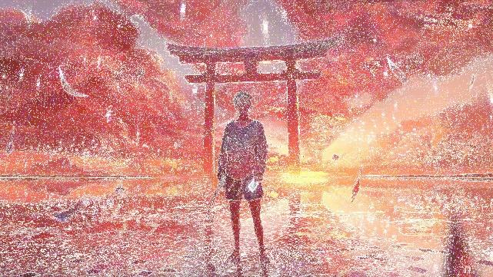
RESULT:-
Thus the program is executed successfully.
25. Perform Sharpening of Image using Gradient masking.
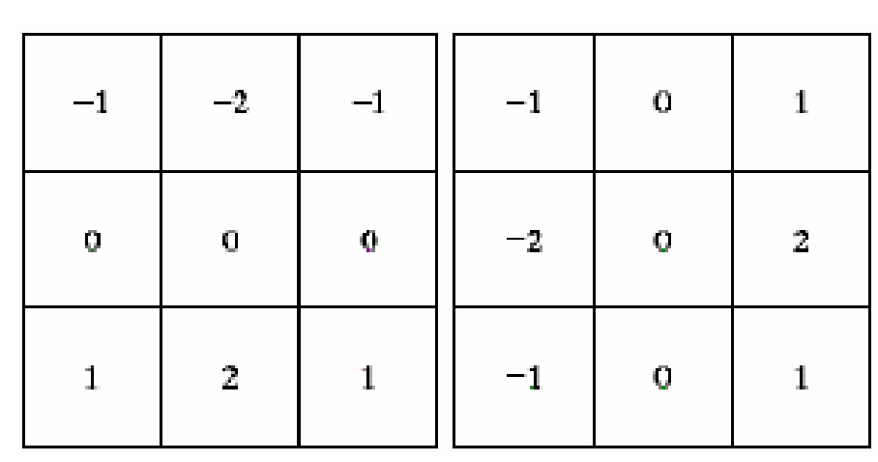
AIM:- Sharpening of Image using Gradient masking
PROGRAM:-
import cv2
import numpy as np
image_path = "C:\\Users\\girishma\\Desktop\\OpenCV\\image1.jpg"
image = cv2.imread(image_path)
gray = cv2.cvtColor(image, cv2.COLOR_BGR2GRAY)
gradient_x = cv2.Sobel(gray, ddepth=cv2.CV_64F, dx=1, dy=0, ksize=3)
gradient_y = cv2.Sobel(gray, ddepth=cv2.CV_64F, dx=0, dy=1, ksize=3)
gradient = cv2.subtract(gradient_x, gradient_y)
cv2.imwrite('sharpened_image3.jpg', gradient)
INPUT:-
OUTPUT:-
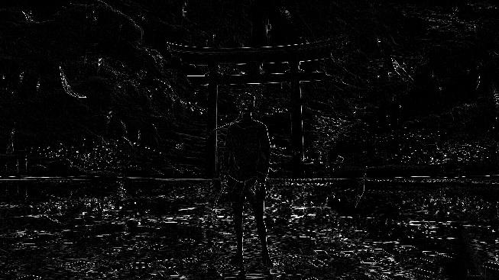
RESULT:-
Thus the program is executed successfully.
26. Insert water marking to the image using OpenCV.
AIM:- Insert water marking to the image using OpenCV
PROGRAM:-
import cv2
import math
logo = cv2.imread("C:\\Users\\girishma\\Desktop\\OpenCV\\image1.jpg'")
img = cv2.imread("C:\\Users\\girishma\\Desktop\\OpenCV\\image2.jpg'")
h_logo, w_logo, _ = logo.shape
h_img, w_img, _ = img.shape
center_y = int(h_img/2)
center_x = int(w_img/2)
top_y = center_y - int(h_logo/2)
left_x = center_x - int(w_logo/2)
bottom_y = top_y + h_logo
right_x = left_x + w_logo
destination = img[top_y:bottom_y, left_x:right_x]
result = cv2.addWeighted(destination, 1, logo, 0.5, 0)
img[top_y:bottom_y, left_x:right_x] = result
cv2.imshow("watermarked.jpg", img)
cv2.imshow("Watermarked Image", img)
cv2.waitKey(0)
cv2.destroyAllWindows()

INPUT:-
Img1:-
Img2:-
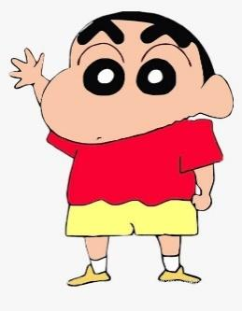
OUTPUT:-
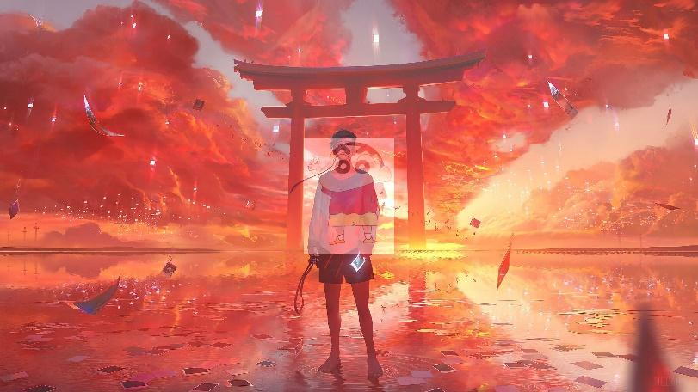
RESULT:-
Thus the program is executed successfully.
27. Do Cropping, Copying and pasting image inside another image using OpenCV.
AIM:- Cropping, Copying and pasting image inside another image using OpenCV.
PROGRAM:-
#For cropping
import cv2
img = cv2.imread("C:\\Users\\girishma\\Desktop\\OpenCV\\image1.jpg")
# Crop the image from (x, y) = (10, 10) to (x, y) = (300, 300)
crop_img = img[10:300, 10:300]
cv2.imshow("cropped", crop_img)
cv2.waitKey(0)
cv2.destroyAllWindows()
#For copy and paste
import cv2
img1 = cv2.imread(“C:\\Users\\sreeh\\Desktop\\OpenCV\\image1.jpg”)
img2 = cv2.imread(“C:\\Users\\sreeh\\Desktop\\OpenCV\\image2.jpg”)
rows, cols, channels = img2.shape
roi = img1[50:50+rows, 50:50+cols]
img2gray = cv2.cvtColor(img2, cv2.COLOR_BGR2GRAY)
ret, mask = cv2.threshold(img2gray, 10, 255, cv2.THRESH_BINARY)
mask_inv = cv2.bitwise_not(mask)
img1_bg = cv2.bitwise_and(roi, roi, mask=mask_inv)
img2_fg = cv2.bitwise_and(img2, img2, mask=mask)
dst = cv2.add(img1_bg, img2_fg)
img1[50:50+rows, 50:50+cols] = dst
cv2.imshow('result', img1)
cv2.waitKey(0)
INPUT:-
OUTPUT:- (for cropped)
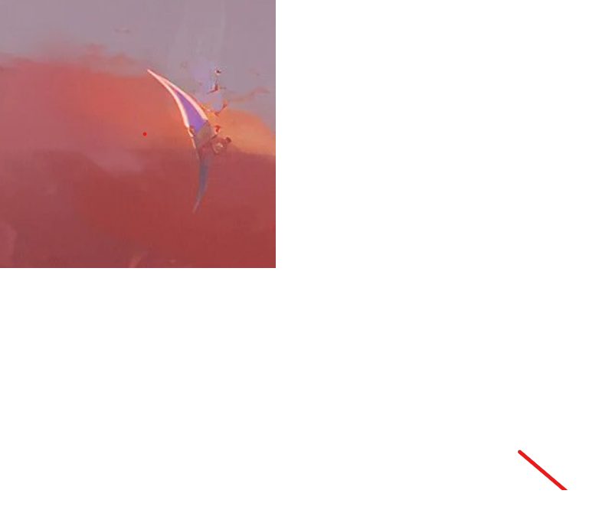
(for copy and paste)
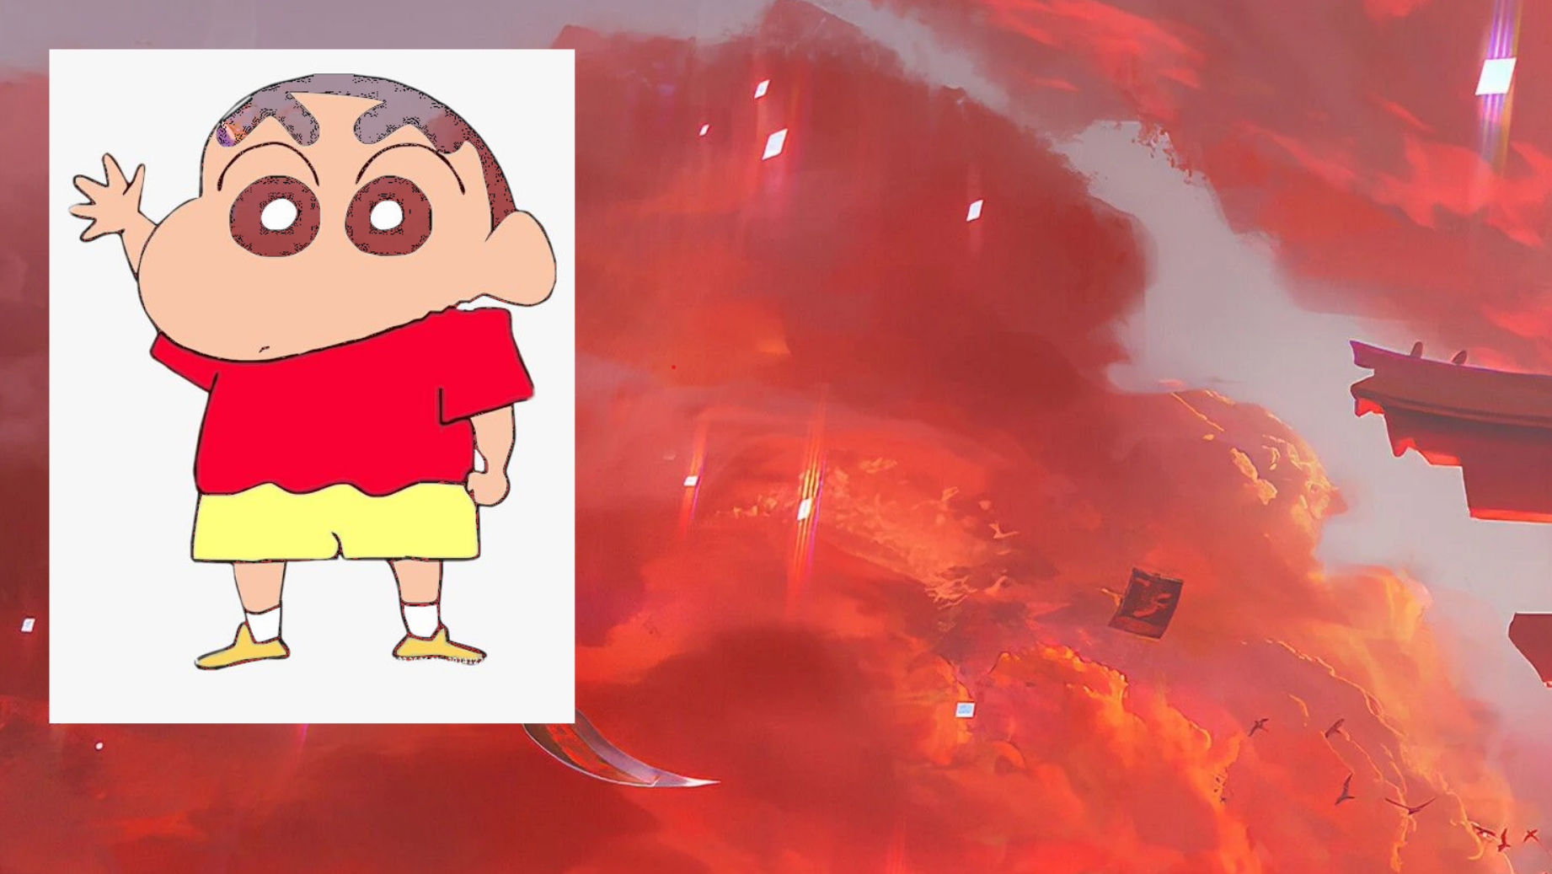
RESULT:-
Thus the program is executed successfully.
28. Find the boundary of the image using Convolution kernel for the given image.
AIM:- The boundary of the image using Convolution kernel for the given image.
PROGRAM:-
import cv2
import numpy as np
img = cv2.imread("C:\\Users\\girishma\\Desktop\\OpenCV\\image1.jpg")
kernel = np.array([[-1,-1,-1],[-1,9,-1],[-1,-1,-1]])
sharpened_img = cv2.filter2D(img, -1, kernel)
cv2.imshow('Input Image', img)
cv2.imshow('convolutional Image', sharpened_img)
cv2.waitKey(0)
cv2.destroyAllWindows()
INPUT:-
OUTPUT:-
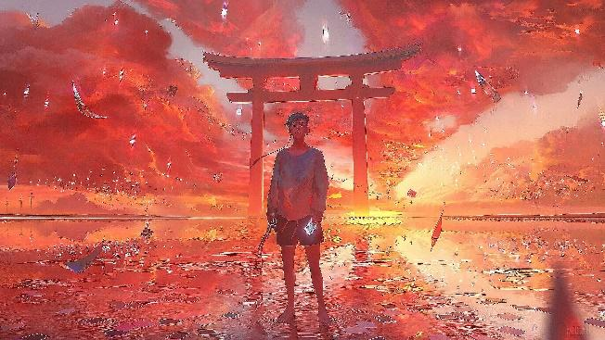
RESULT:-
Thus the program is executed successfully.
29. Morphological operations based on OpenCV using Erosion technique.
AIM:- Morphological operations based on OpenCV using Erosion technique.
PROGRAM:-
import cv2
import numpy as np
img = cv2.imread(""C:\\Users\\girishma\\Desktop\\OpenCV\\image1.jpg", cv2.IMREAD_GRAYSCALE)
kernel = np.ones((5, 5), np.uint8)
eroded_img = cv2.erode(img, kernel, iterations=1)
cv2.imshow("Original Image", img)
cv2.imshow("Eroded Image", eroded_img)
cv2.waitKey(0)
cv2.destroyAllWindows()
INPUT:-
OUTPUT:-
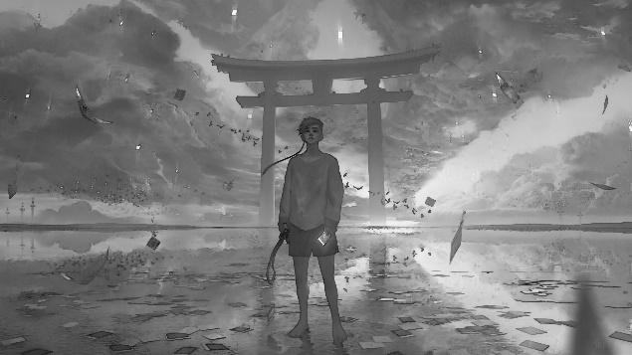
RESULT:-
Thus the program is executed successfully.
30. Morphological operations based on OpenCV using Dilation technique.
AIM:- Morphological operations based on OpenCV using Dilation technique.
PROGRAM:-
import cv2
import numpy as np
img = cv2.imread("C:\\Users\\girishma\\Desktop\\OpenCV\\image1.jpg'")
kernel = np.ones((5,5),np.uint8)
dilation = cv2.dilate(img,kernel,iterations = 1)
cv2.imshow('Original', img)
cv2.imshow('Dilated', dilation)
cv2.waitKey(0)
cv2.destroyAllWindows()
INPUT:-
OUTPUT:-
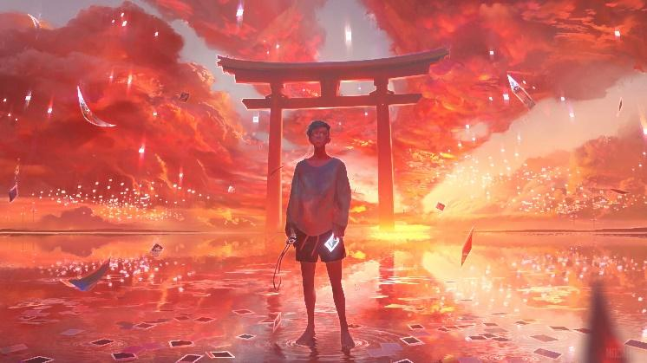
RESULT:-
Thus the program is executed successfully.
31. Morphological operations based on OpenCV using Opening technique.
AIM:-Do morphological operations in an image
PROGRAM:-
import cv2
import numpy as np
img = cv2.imread('C:\\Users\\girishma\\Desktop\\OpenCV\\image1.jpg')
kernel = np.ones((5,5),np.uint8)
opening = cv2.morphologyEx(img, cv2.MORPH_OPEN, kernel)
cv2.imwrite('Opened.jpg', opening)
INPUT:-
OUTPUT:-
RESULT:-
Thus the program is executed successfully.
32. Morphological operations based on OpenCV using Closing technique.
AIM:- Morphological operations using Closing technique.
PROGRAM:-
import cv2
import numpy as np
img = cv2.imread('C:\\Users\\girishma\\Desktop\\OpenCV\\image1.jpg', cv2.IMREAD_GRAYSCALE)
kernel = np.ones((5,5), np.uint8)
closing = cv2.morphologyEx(img, cv2.MORPH_CLOSE, kernel)
cv2.imwrite('Closing.jpg', closing)
INPUT:-
OUTPUT:-
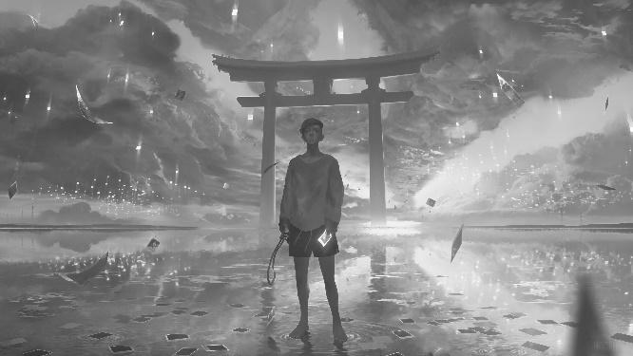
RESULT:-
Thus the program is executed successfully.
33. Morphological operations based on OpenCV using Morphological Gradient technique.
AIM:- Morphological operations using Morphological Gradient technique.
PROGRAM:-
import cv2
import numpy as np
img = cv2.imread('C:\\Users\\girishma\\Desktop\\OpenCV\\image1.jpg', 0)
kernel = np.ones((3,3), np.uint8)
gradient = cv2.morphologyEx(img, cv2.MORPH_GRADIENT, kernel)
cv2.imwrite('Morphological_Gradient.jpg', gradient)
INPUT:-
OUTPUT:-
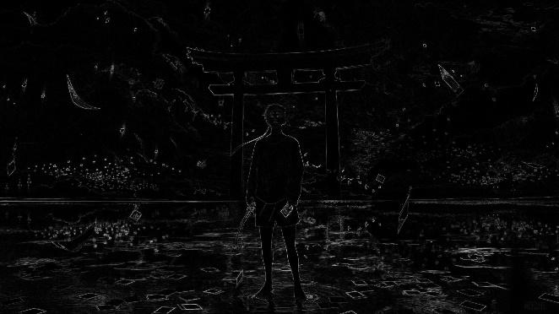
RESULT:-
Thus the program is executed successfully.
34. Morphological operations based on OpenCV using Top hat technique.
AIM:- Morphological operations using Top hat technique.
PROGRAM:-
import cv2
filterSize =(3, 3)
kernel = cv2.getStructuringElement(cv2.MORPH_RECT,filterSize)
input_image = cv2.imread("C:\\Users\\girishma\\Desktop\\OpenCV\\image1.jpg")
input_image = cv2.cvtColor(input_image, cv2.COLOR_BGR2GRAY)
tophat_img = cv2.morphologyEx(input_image,cv2.MORPH_TOPHAT,kernel)
cv2.imwrite("tophat.jpg", tophat_img)

INPUT:-
OUTPUT:-
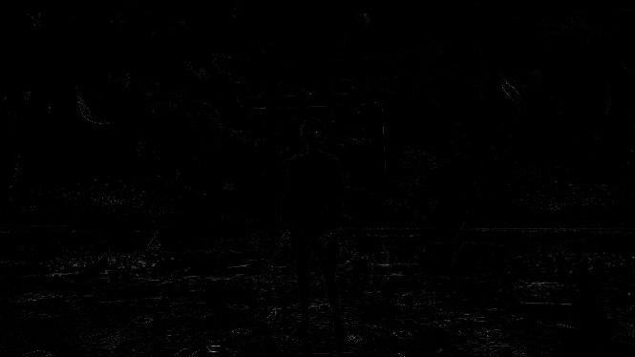
RESULT:-
Thus the program is executed successfully.
35. Morphological operations based on OpenCV using Black hat technique.
AIM:- Morphological operation using Black hat technique.
PROGRAM:-
import cv2
filterSize =(3, 3)
kernel = cv2.getStructuringElement(cv2.MORPH_RECT,filterSize)
input_image = cv2.imread("C:\\Users\\girishma\\Desktop\\OpenCV\\image1.jpg")
input_image = cv2.cvtColor(input_image, cv2.COLOR_BGR2GRAY)
blackhat_img = cv2.morphologyEx(input_image,cv2.MORPH_BLACKHAT,kernel)
cv2.imwrite("blackhat.jpg", blackhat_img)

INPUT:-
OUTPUT:-
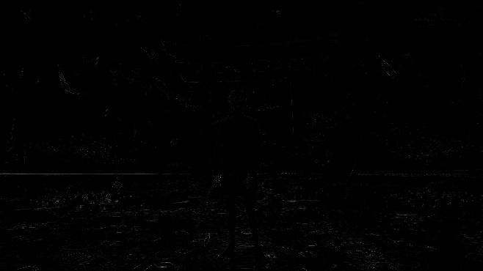
RESULT:-
Thus the program is executed successfully.
36. Recognise watch from the given image by general Object recognition using OpenCV.
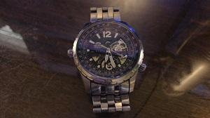
AIM:- Recognise watch from the given image by general Object recognition
PROGRAM:-

INPUT:-
OUTPUT:-
RESULT:-
Thus the program is executed successfully.
37. Using Opencv play Video in Reverse mode.
AIM:- Play Video in Reverse mode
PROGRAM:-
import cv2
cap = cv2.VideoCapture("C:\\Users\\girishma\\Desktop\\demonslayer.mp4")
num_frames = int(cap.get(cv2.CAP_PROP_FRAME_COUNT))
for i in reversed(range(num_frames)):
cap.set(cv2.CAP_PROP_POS_FRAMES, i)
ret, frame = cap.read()
cv2.imshow('Reverse Video', frame)
if cv2.waitKey(25) & 0xFF == ord('q'):
break
cap.release()
cv2.destroyAllWindows()
INPUT:-
#TO RUN THIS CODE” video/demonslayer.mp4 at main · Muttamatam-Sreeharsha-0471/video (github.com)”DOWNLOAD VIDEO VIA THIS LINK
OUTPUT:-
The video will run in reverse mode.
RESULT:-
Thus the program is executed successfully.

38. Face Detection using Opencv.
AIM:- Face Detection
PROGRAM:-
import cv2
face_cascade = cv2.CascadeClassifier(cv2.data.haarcascades + 'haarcascade_frontalface_default.xml')
cap = cv2.VideoCapture(0)
while True:
ret, frame = cap.read()
gray = cv2.cvtColor(frame, cv2.COLOR_BGR2GRAY)
faces = face_cascade.detectMultiScale(gray, scaleFactor=1.1, minNeighbors=5, minSize=(30, 30))
for (x, y, w, h) in faces:
cv2.rectangle(frame, (x, y), (x+w, y+h), (0, 255, 0), 2)
cv2.imshow('Face Recognition', frame)
if cv2.waitKey(1) & 0xFF == ord('q'):
break
cap.release()
cv2.destroyAllWindows()
OUTPUT:-
It will access the cam and detect the face.
RESULT:-
Thus the program is executed successfully.

39. Vehicle Detection in a Video frame using OpenCV .
AIM:- Vehicle Detection in a Video frame
PROGRAM:-
INPUT:-
OUTPUT:-
RESULT:-
Thus the program is executed successfully.

40. Draw Rectangular shape and extract objects.
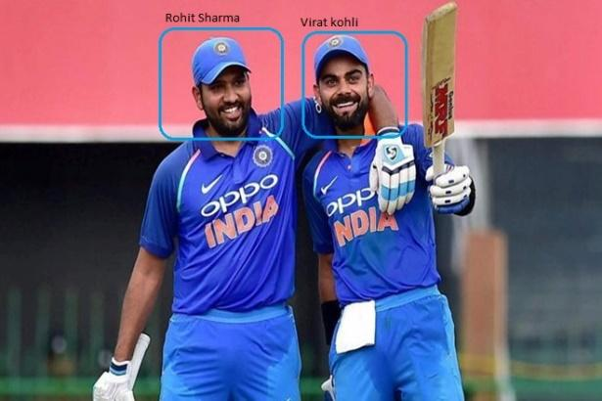
AIM:- Draw Rectangular shape and extract objects
PROGRAM:-
import cv2
img = cv2.imread("C:\\Users\\girishma\\Desktop\\OpenCV\\image1.jpg")
start_point = (50, 50)
end_point = (200, 200)
color = (0, 0, 255)
thickness = 2
rect_img = cv2.rectangle(img, start_point, end_point, color, thickness)
cv2.imshow('Image with Rectangle', rect_img)
cv2.waitKey(0)
obj_img = img[start_point[1]:end_point[1], start_point[0]:end_point[0]]
cv2.imshow('Extracted Object', obj_img)
cv2.waitKey(0)
cv2.imwrite('object.jpg', obj_img)
cv2.destroyAllWindows()

INPUT:-
OUTPUT:-
RESULT:-
Thus the program is executed successfully.

